Update on coastal path proposals.

The Secretary for State has decided to approve Natural England’s proposals for sections BHW1 (Birkenhead to Red Rocks) and BHW3 (Boathouse pub to Welsh border), but as yet there is no decision on BHW2 (Red Rocks to Boathouse pub). This relevant letter is in the email.

The Parkgate Society made representation during the consultation, mainly concerning access rights to the marsh. Natural England’s response to this is recorded in Appendix 1, and the Secretary for State’s acceptance of that response is included in Appendix 2. Essentially our concerns have been not been accepted (for the reasons explained below).

There were numerous representations which have been “answered”, very largely in the same way as the Parkgate Society’s. The interested reader may wish to plough through scores of pages (available through the links in the Secretary of State’s letter) but these can be distilled down to these essentials for the BHW3 section (Boathouse pub to Welsh border):

- The section from the Old Quay pub to the bottom of Moorside Lane will run along Manorial Road, rather than any new path along the marsh edge (reasons: birdlife etc, access for those with restricted mobility)
- The section of path around Burton Point (path from Station Road Burton, around Burton Point to the Welsh Border) will have a restriction in exclusion of access for up to 20 days per year (reasoning: livestock management during very high tide), though it is envisaged that in practice it will be far less than this and no different from now (note to right of way presently, only by landowner permission)
- The projected capital costs outlined in the original document are defended (though still seem too low). It is of note that it is explicitly stated that this does NOT include any funds for provision of a fence between the path and the marshes.
Item | Cost
Signs & interpretation | £ 18,000
Fencing | £ 1,500
Surfacing, boardwalks and drainage | £ 28,620
Border feature | £ 10,000
Project management | £ 5,815
Total | £63,935 (Exclusive of any VAT payable)

- The projected maintenance costs are defended as being compatible with a national formula used elsewhere (£1365 + VAT).
- The main contentious issue, and by far the most numerous in the representations (based on a number of assertions), related to the proposed exclusion of access right to the marshes. The following are the most pertinent points:
  - It has been decided to exclude all access to a strip of land just to the seaward side alongside the existing path which extends from Burton Point northwards to a line which is somewhere along the northern part of the present cycle path from the south end of Quayside to Denhall Lane. The precise location of this northerly edge is not clear, since it is shown at different points on the different maps in the documents, but on the Map BHW3C (which seems most definitive) this coincides with a pre-existing fence used to restrict livestock movement.

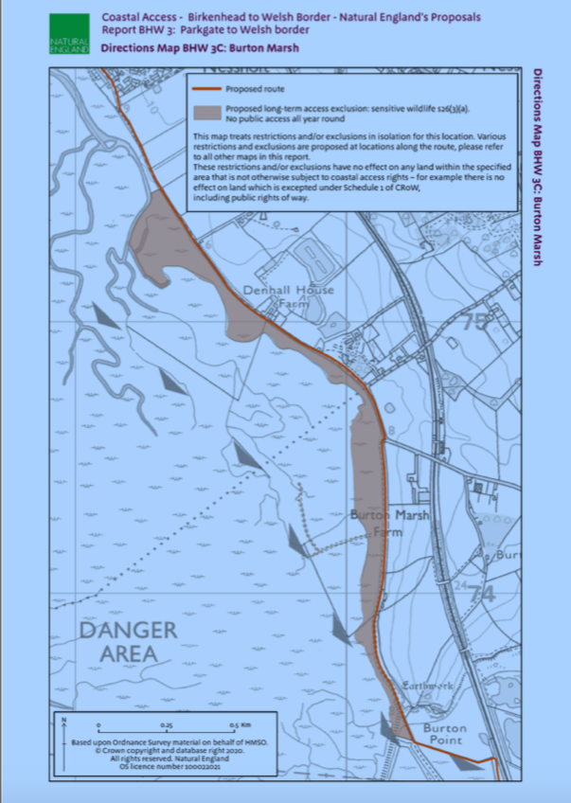
This exclusion is explained:

3.2.19 Access to the land in the coastal margin seaward of route sections BHW-3-S042 to BHW-3-S044 is to be excluded all year round, by direction under section 26(3)(a) of the Countryside and Rights of Way Act (2000), to prevent disturbance to birds. This exclusion does not affect the route itself and will have no legal effect on land where coastal access rights do not apply. See Directions Map BHW 3C.
- There is no exclusion of access rights for that area of the marshes between the Old Quay (not the pub but the true Old Quay, near the sewerage works) and Denhall Quay (just south of the Harp pub), with the seaward boundary formed by the main ditches already in existence. It is recognised that this area is frequented by walkers and their dogs, and is generally drier and safer than the other areas of the marsh. There are two points to note here:
  - For the reasons outlined below (in red), this means that new public access rights will be established for this area, since it is seaward of the coastal path
  - The northerly and southerly borders of this area are not clear cut on the maps (differ slightly from map to map). However, on the ground, the northerly edge is very clear (a large ditch) whilst the southerly edge relates to the same issue as in 5a above. In practice, I doubt this will be a problem

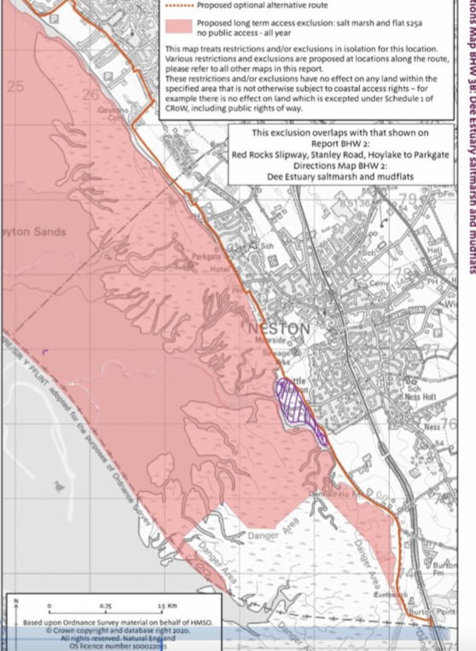

The proposals exclude public access rights arising from this coastal path to all of the rest of the marsh. The justifications for this are claimed to be public safety (whatever the local opinion on this may be) and lack of other ways of protecting this; and protection of birdlife and obligations under various pre-existing regulations/laws. Natural England’s position on this (oft repeated in their responses to numerous representations) is given in Appendix 1, their response to the Parkgate Society’s representation. They are evidently using section 25A of the Marine and Coastal Access Act 2009, and say that if this did not succeed they would move to use section 26. However in fairness to Natural England they do point out:
We should like to clarify that any proposed exclusion in our reports relates only to a new right of access under the Marine and Coastal Access Act 2009 and does not affect public rights of way or other access rights in any way. There is no suggestion on our part that we are prohibiting or banning public access from the marsh, other than in relation to the new right of access proposed in our reports. However, it is important to understand that historic use of an area does not necessarily indicate the presence of existing access rights.
One should understand the situation regarding the new coastal path which automatically establishes new public rights of access along the path and also all land on its seaward side unless explicitly excluded (the italics are mine for emphasis). This is outlined in the “Overview” document (available through the links in the Secretary of State’s letter)
- v Land which forms part of the coastal margin would be subject to access rights, other than:
  - any excepted land, such as land covered by buildings or their gardens or curtilage: Annex C summarises in full the categories of excepted land under the legislation; or
  - any land where coastal access rights would be excluded under our statutory powers: we indicate in the report where we already know of circumstances that make this necessary, and make any proposals accordingly.
- vi Spreading room is the term used in the reports to describe any land,other than trail land,which would form part of the coastal margin and would have public rights of access. It does not therefore include any excepted land within the margin, or any existing access land on the landward side of the trail that is omitted from the margin.
- vii Voluntary access dedication: Land that was previously dedicated as access land under section 16 of the Countryside and Rights of Way Act 2000 (CROW) will become subject to the coastal access regime if it forms part of the coastal margin in any of the ways described above. There is also provision in the legislation for a land owner or long leaseholder to dedicate other land voluntarily as coastal margin if it lies adjacent to it or within it. Dedicating land as coastal margin means the excepted land provisions do not apply there and may also be used to relax or remove specific national restrictions that would otherwise apply. Parts 4.8.20 to 4.8.23 of the Coastal Access Scheme explain these provisions in more detail.

Appendix 1
Representation ID: MCA/BHW3/R/10/1032
Organisation/ person making representation:
[Redacted] (Parkgate Society)
Name of site: Not specified
Report map reference: Not specified
Route sections on or adjacent to the land: Not specified, but assumed to be BHW-3-S001 to S044
Other reports within stretch to which this representation also relates N/A
Summary of representation: The representation focuses on the proposed direction to exclude access to the salt marsh within the coastal margin associated with this report length, in terms of a suggested further reduction of access, and states that it wishes to endorse the representation submitted by [redacted]. It goes on to relate a long history of limited access to the marsh, including a path leading onto the marsh from the end of Marshlands Road. Finally, the respondent states that he is not aware of any serious incidents related to the use of the marsh by local people.
Natural England’s comment: We should like to clarify that any proposed exclusion in our reports relates only to a new right of access under the Marine and Coastal Access Act 2009 and does not affect public rights of way or other access rights in any way. There is no suggestion on our part that we are prohibiting or banning public access from the marsh, other than in relation to the new right of access proposed in our reports. However, it is important to understand that historic use of an area does not necessarily indicate the presence of existing access rights.
The Marine and Coastal Access Act 2009 explicitly recognises that the coast is an inherently risky environment and that walkers must be largely responsible for their own safety, when exercising their new rights. However, the legislation also gives powers to Natural England to consider whether some areas of salt marsh or flat are unsuitable for access; we are obliged to exercise discretion in relation to this power as objectively as possible and to only propose exclusions where we believe that it makes sense to do so.
We must carefully consider whether any such exclusions (or restrictions) are required in relation to our proposals – either for nature conservation reasons or access suitability reasons. In this case, we concluded that it would be necessary to exclude any new right of access from a large part of the coastal margin on grounds that we do not consider it suitable for such a right. This conclusion must take into account the risks posed to visitors from further afield, who may not appreciate the terrain and effects of the tides in the same way as might local people. We should also clarify that a historic record of incidents and rescues, alongside other advice provided by bodies such as the RNLI and HM Coastguard, is just one factor that we take into consideration when deciding whether or not we believe an access exclusion is required; we also take into account a wide range of factors such as the presence and nature of tidal creeks, the extent to which the area is affected by tidal inundation, the risk of being caught by an incoming tide and the difficulty in escaping from such a rising tide.
In the case of European sites, we have a specific duty to assess the implications of our proposals to introduce coastal access rights on the sites’ conservation objectives. Our Habitats Regulations Assessment (HRA), published alongside our proposals for this European site (the Dee Estuary SPA/SAC), concludes that there would be significant concerns about the impact on nature conservation from any disturbance created by the new coastal access rights on the saltmarsh.
We have not proposed an additional exclusion under s26 as to do so would serve no purpose; however, if the s25A exclusion were not to be approved or were to be subsequently removed, we would need to review the Habitats Regulations Assessment with the possible outcome being that a new direction to exclude access under s26 (for nature conservation purposes) would be made over a similar area.

Appendix 2
Representation No MCA/BHW3/R/10/1032Name of representation: Member of the Parkgate Society
Length Report and route section(s): Length Report 3, BHW-3-S001 to BHW-3-S044
Secretary of State’s conclusion and observation: Secretary of State notes Natural England’s reasoning for its use of directions. Considers that directions have been applied appropriately throughout and with due consideration to walkers, wildlife and other interested parties.

birkenhead-welsh-border-report-3.pdf

Appendix Pages https://assets.publishing.service.gov.uk/government/uploads/system/uploads/attachment_data/file/999106/birkenhead-welsh-border-representations-ne-comments.pdf

Representation No MCA/BHW3/R/10/1032
Name of representation: Member of the Parkgate Society
Length Report and route section(s): Length Report 3, BHW-3-S001 to BHW-3-S044
Secretary of State’s conclusion and observation: Secretary of State notes Natural England’s reasoning for its use of directions. Considers that directions have been applied appropriately throughout and with due consideration to walkers, wildlife and other interested parties.

https://assets.publishing.service.gov.uk/government/uploads/system/uploads/attachment_data/file/944514/birkenhead-welsh-border-overview.

